**DIGITAL FORENSIC REPORT I**

Details

* The tool used: Autopsy Version 4.19.3 for Windows System
* Analysed File Name: Hunter XP. E01
* Analysed File Type: Disk Image
* Analysed File Size: 558 MB (58,52,30,499 bytes)

Name: Gargi Sarkar

Course: Cybercrime investigation and OSINT training

1. Introduction

This report contains the results of an analysis performed on a sample of digital evidence collected by law enforcement using the "Autopsy" tool. The analysis indicates that Bob Hunter and Billy Ray stalked two young women with the intent to kidnap them and use the resulting photographs as blackmail against the girls' respective fathers. They resorted to cyber extortion and planned to build up a website where the girls' photographs would be publicly broadcast, and they continued to speak with the girls' families in exchange for a $500,000 ransom. According to the names and messages, Christina's father is John Detsiwt, and Sabrina's is Ted Dewercs. After mistaking Christina for a girl named Kim, the contents of the device and the girls' communications show that they are, in fact, Christina and Sabrina, and the narrative continues.

1. Summary of the evidence analysis process

The images of the two girls were found in a folder titled "Images," and our investigations led us to believe that the digital evidence we had acquired pointed to the likelihood of a crime against them. The nature of these images suggests that two girls were being followed and observed and that they were photographed without their knowledge in a variety of settings, including a home, a supermarket, the mall, the street, a library, a garden, a cafe, and a beach. During the investigation, it was discovered that both Bob Hunter (at Chaser1191@hotmail.com) and Bailey Ray (at billyray150@hotmail.com) exchanged emails with each other. The content of their exchanges centred on the two girls, their families, and their relationships. Everything from stalking to abductions to setting up ransom and the tactics necessary to get there were discussed in detail in the emails between the two of them. The father of the girls was intimidated, and a large ransom was demanded in exchange for the girls' freedom.

1. The Images and Emails as an Evidence

* The image (725-102-0283_IMG modified on 2002-04-24) shows the reflection of a person's appearance on the glass while he is photographing one of the girls.

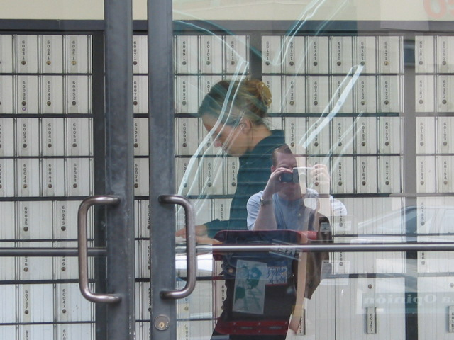

* One of the stalkers snapped a selfie while Christina walked by him in such a way that it appeared they took a selfie together. However, based on the photographs, it appears she was passing by when the photo was taken.

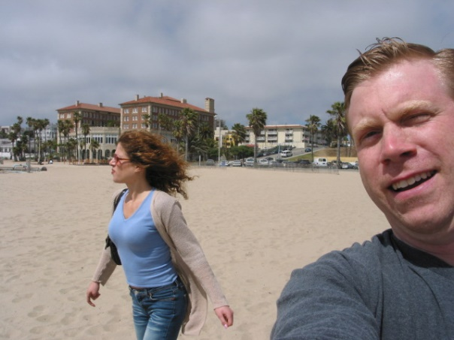 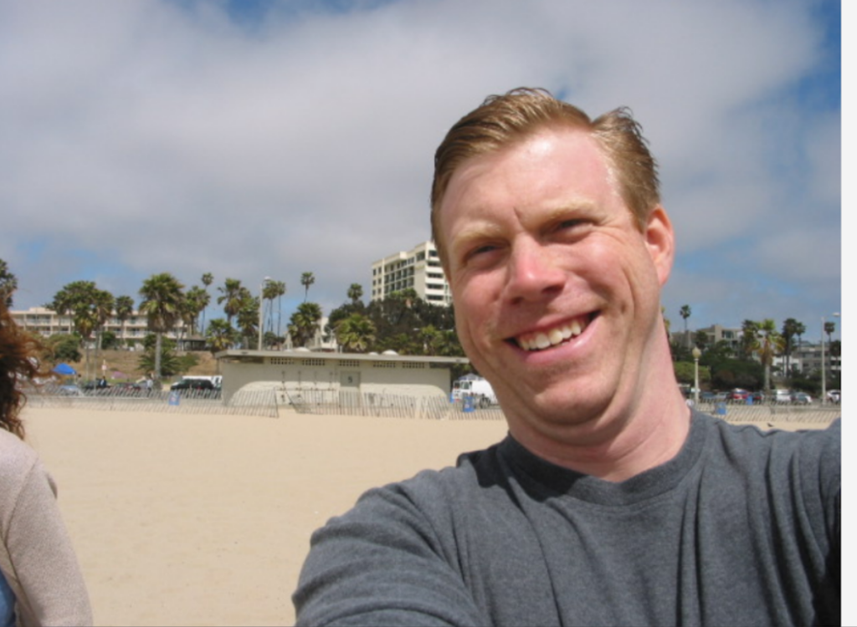

* They involved Cristiana's friend Sabrina in the stalking. Bob Flying to the girls' city to gather more information.

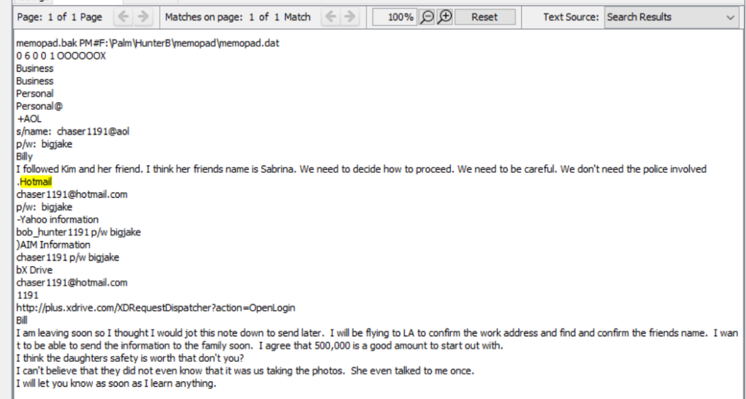

* Scouting on Christina and Sabrina.

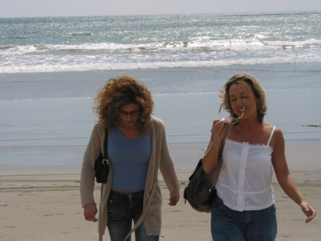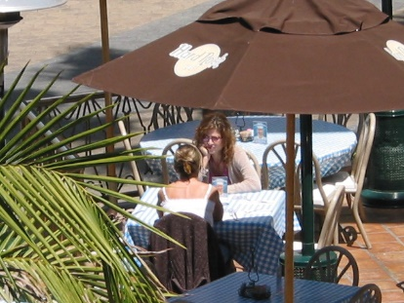 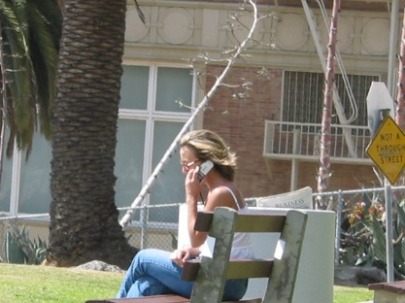

* Billy gathered the fathers' email addresses and forwarded them to Bob.

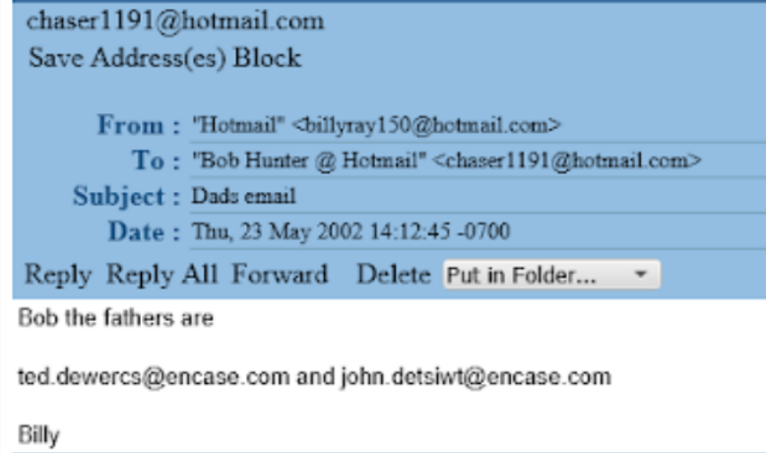

* They found the Girls' address and location.

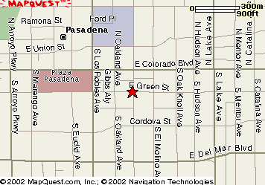

* Billy made Bob read a website on stalking techniques.

* Billy and Bob had a conversation regarding the latest developments in the stalking and the ransom for the girl's kidnapping.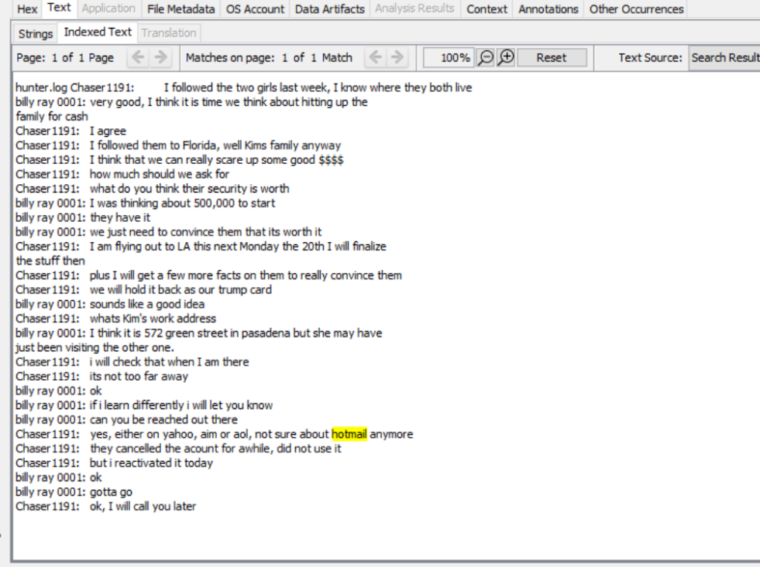

* A mail was sent to Bob from **John Detsiwt**, "John.Detsiwt@guidancesoftware.com", with the subject line "Bank Name, Account and Routing Numbers" and the body reading "Bank of America 14921-24927 294812918. Please don't injure her!"

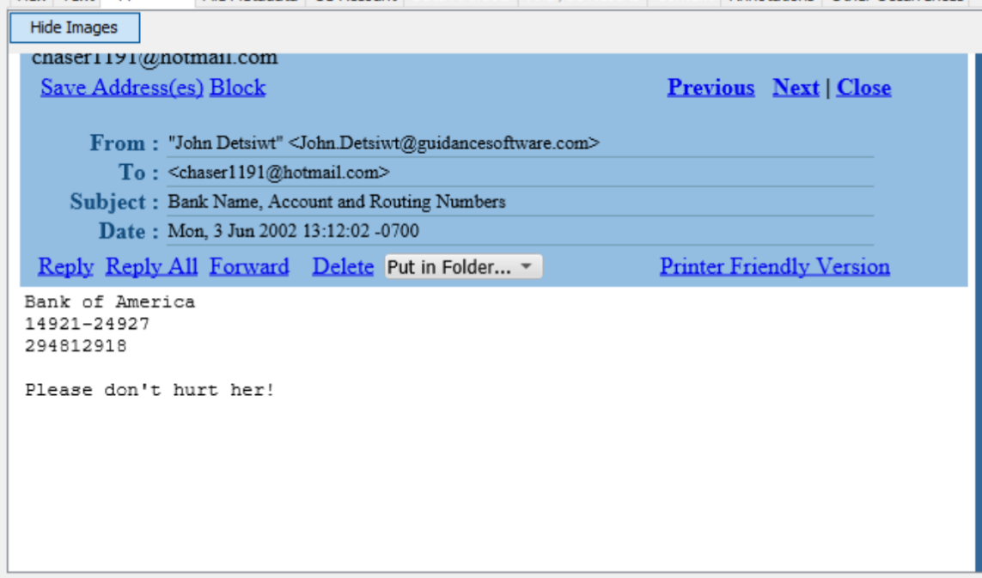

* The following message was sent to Bob (chaser1191@hotmail.com) from **Ted Dewercs** ([ted.dewercs@guidancesoftware.com](mailto:ted.dewercs@guidancesoftware.com)) when he asked for ransom.

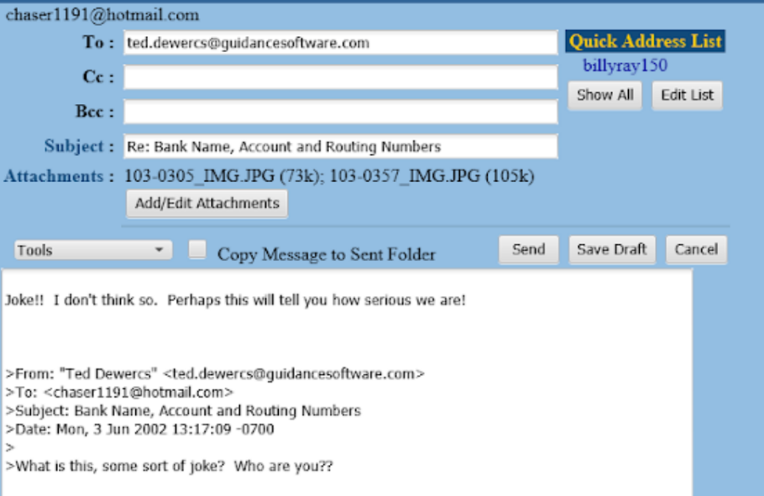

* They are setting up a webpage to upload the girls' photos.

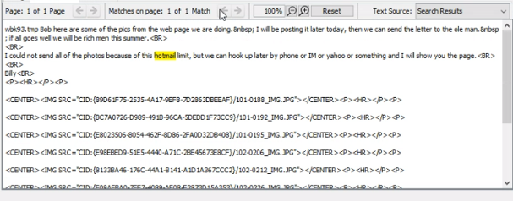

* Sample of the webpage with captions sent to the girls' fathers.

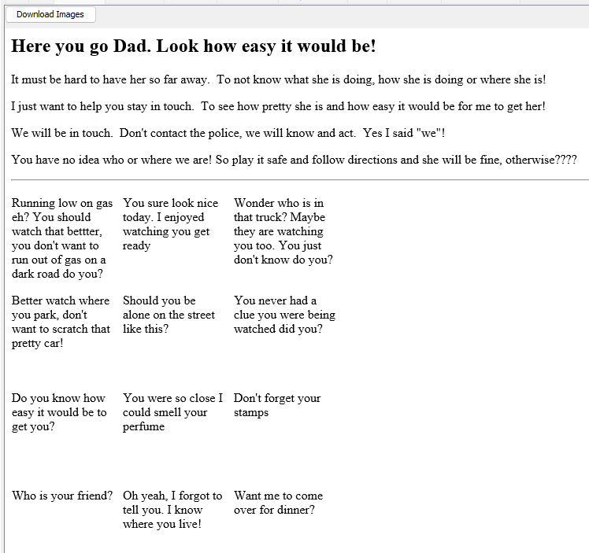

Conclusion

It was discovered that the two suspects, Bob and Billy, had been keeping tabs on two girls (Christina and Sabrina), plotting their abduction, collecting information and photographs about them, and taking these to blackmail the girls' respective fathers, John and Ted, into paying them a total of $500,000 for the girls' safety. John responded by providing his bank account information and routing number and requesting that they not harm his daughter. However, we are unsure whether or not Ted was seriously threatened because we received a communication from Ted to bob in which it was written, "What is this? Is it some type of joke?" We are also unsure if they received the money they requested from their fathers because we could not locate any documentation to support this claim.